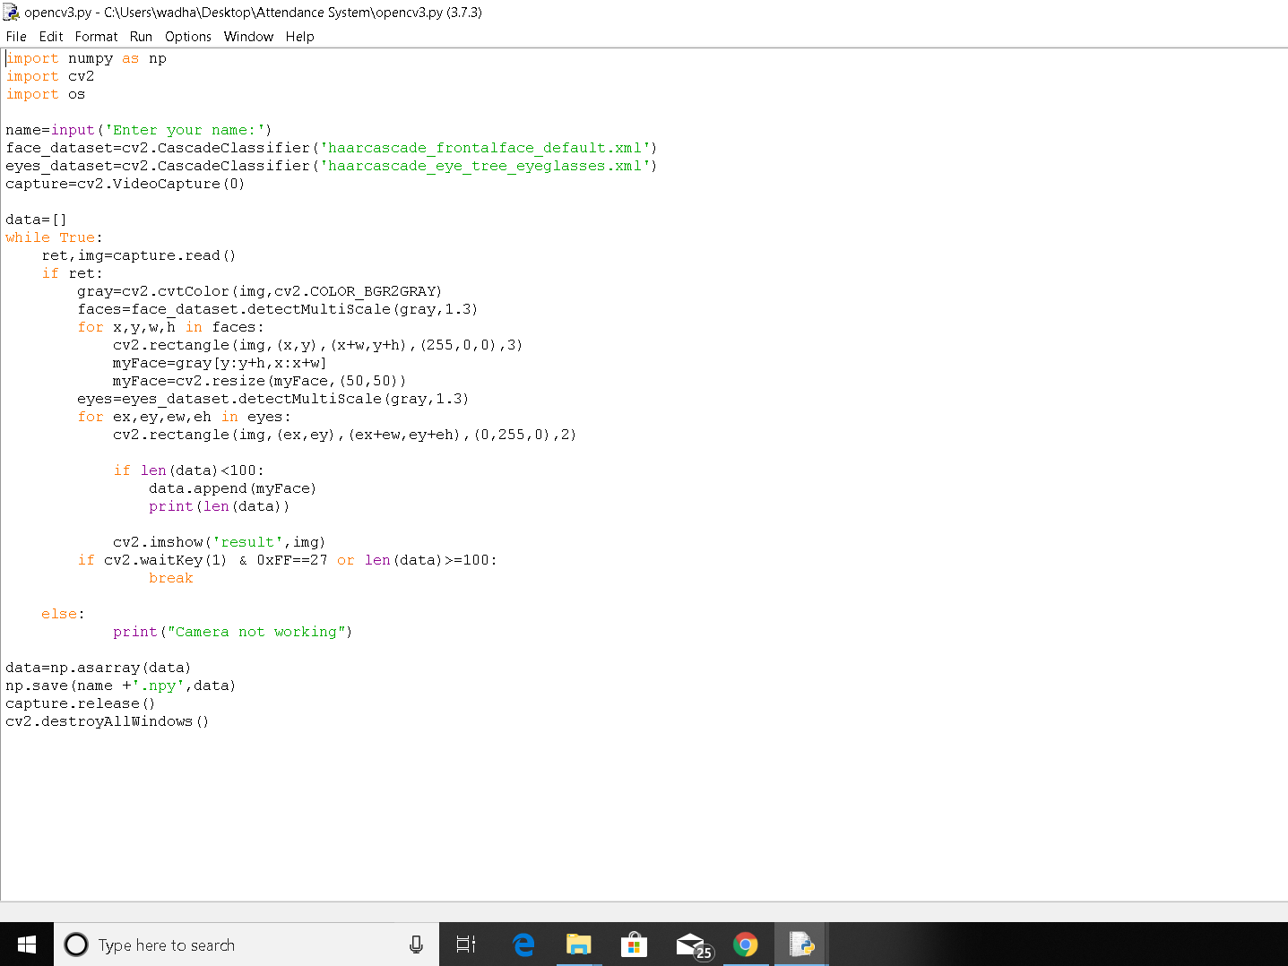

Fig.a

In the above figure we are making a dataset of the students who we want in our system. This procedure first takes the images and then converts them into grayscale. The images are then scanned for the faces and eyes of the person using the haar cascade classifiers. Once we save hundred images of each student, the images are stored in a numpy array with ‘.npy’ extension.